TOPIC 1: 3-DIMENSIONAL SHAPES
3-Dimensional shapes (3-D shapes) refers to object that are centered on three major parameters, i.e. The height, the length and the breadth. Unlike 2-D shapes that can be drawn on flat paper since they have only two parameters (length and breadth), 3-D shapes can accurately be constructed on the reality plane. In fact, most objects in real life are 3-D shapes (e.g. seasoning cubes, houses, ATM cards, etc.)
Objectives: At the end of the session, the students will be able to:
- Explain and identify various 3-D shapes.
- Determine the curved surface area and total surface area of various 3-D shapes.
- Determine the volume of various 3-D shapes, as well as the volumes of frustums of various 3-D shapes.
There are various shapes that exist and are bounded by the parameters of length, breadth and height. Some of these 3-D shapes include; cube, cuboid, cone, cylinder, triangular prism.
For all these shapes, the relationships between their parameters or sides differ ever so slightly.
- CUBE:
This is a symmetrical 3-D shape, formed from the conjunction of six equal squares.
Predominantly, all the sides in a cube are equal; of course, this follows since squares have equal sides as well.
SURFACE AREA OF A CUBE
Consider a cube of equal sides, L; then the total surface area is simply the addition of the areas of each square that forms the cube.
Area of Square with sides, L=$L^{2}$
Thus, surface area of cube= 6$L^{2}$
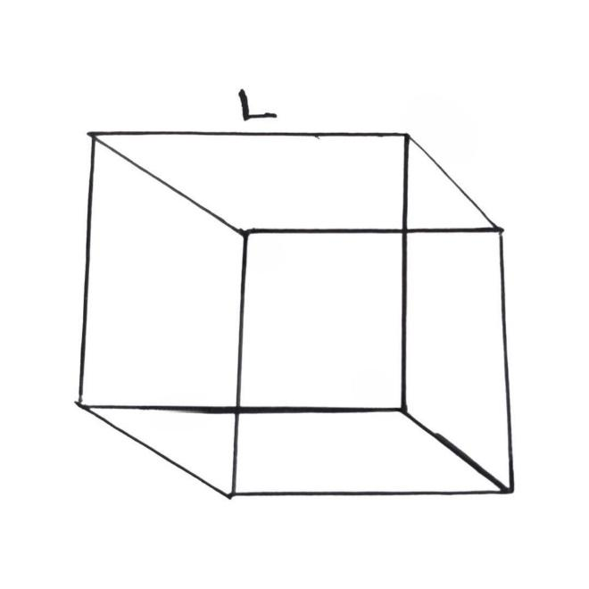

VOLUME OF A CUBE
This refers to the amount of space contained or enclosed within the cube. With the sides of the cube as L,
Volume of cube = $L^{3}$

- CUBOID
This is a 3-D shape formed from six combined rectangles or in some cases, five rectangles and two squares. There are three distinct sides within the cuboid. These are the LENGTH, BREADTH and HEIGHT.
SURFACE AREA OF A CUBOID
Then, the total surface area is simply the addition of the area of each 2-D shape that from the side.
So, Surface Area of Cuboid= 2(LH + BH + LB)
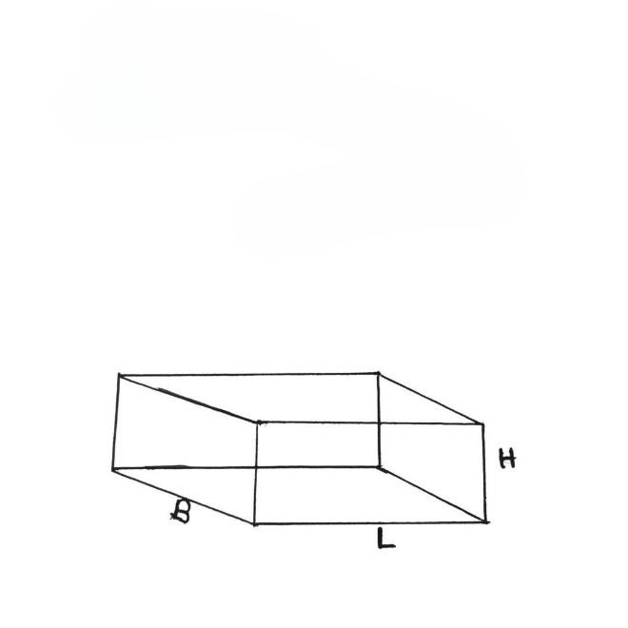

VOLUME OF A CUBOID
This is the amount of space contained or enclosed within the cuboid. With the distinct sides of the cuboid being L, B and H.
Volume of Cuboid = LBH
- CYLINDER
This is a 3-D shape formed from the combination of circles of equal radius and a 2-D shape (usually a square or rectangle). The distinct features of the cylinder is the radius and its height.
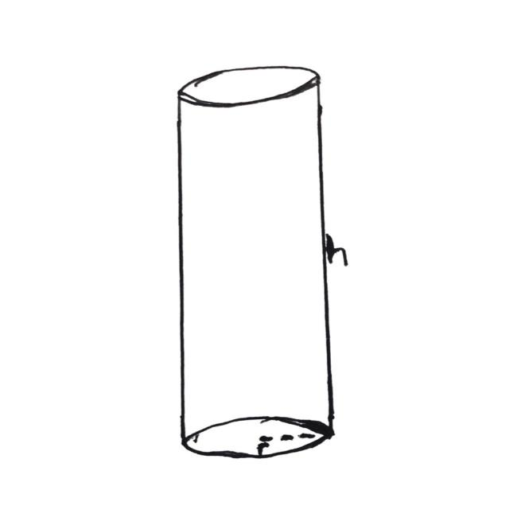

CURVED SURFACE AREA (C.S.A)
C.S.A of cylinder = 2$πrh$
TOTAL SURFACE AREA (T.S.A)
T.S.A of cylinder= 2$\left(πr^{2}\right)+2πrh$
= $2πr(r+h)$
VOLUME OF CYLINDER
Volume of Cylinder = $πr^{2}h$
- CONE
The cone is a 3-D shape formed from the bending of a major sector. The distinct features of a cone are the radius and its depth, which is the height and the slant height, which is the original radius of the sector.
R is usually denoted by l, to indicate slant height.
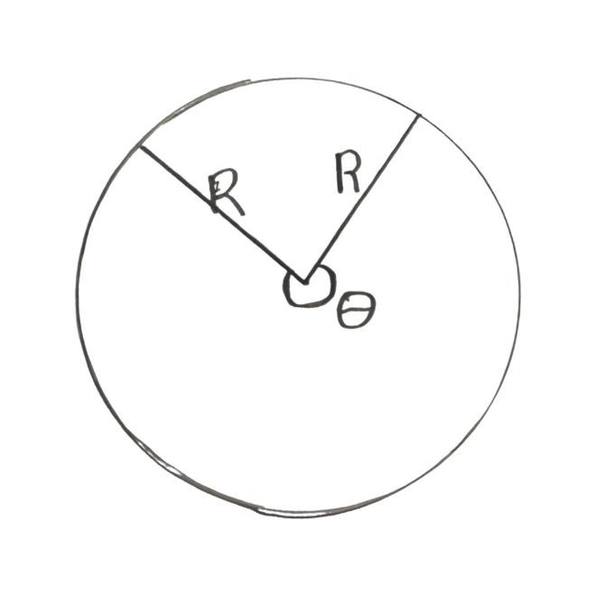

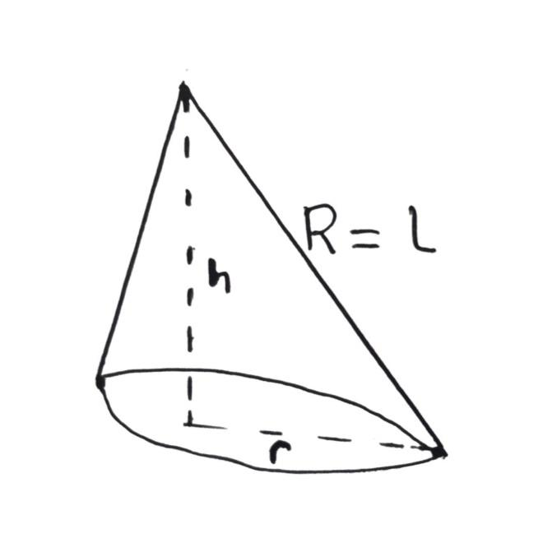

CURVED SURFACE AREA (C.S.A)
C.S.A of cone= $πrl$
TOTAL SURFACE AREA (T.S.A)
T.S.A of cone = $\left(πr^{2}\right)+πrl$
= $πr(r+l)$
VOLUME
Volume of Cone = $\frac{1}{3}πr^{2}h$
- PYRAMIDS
Pyramids are 3-D shapes that are simply a portion of the original 3-D shape. Just as the cone is simply a portion (one-third) of the cylinder, specific pyramids are also portions of their original shapes. In general, the volume of a 3-D shape is the product of the base area and its height. There are two common classes of pyramids that stand out from the rest.
  - SQUARE BASED PYRAMIDS
Volume = = $\frac{1}{3}L^{2}h$
The square based pyramid is simply one-third of the 3-D shape where the base sides are equal. This can either be a cube (in which case h=l) or a cuboid (with a square base).
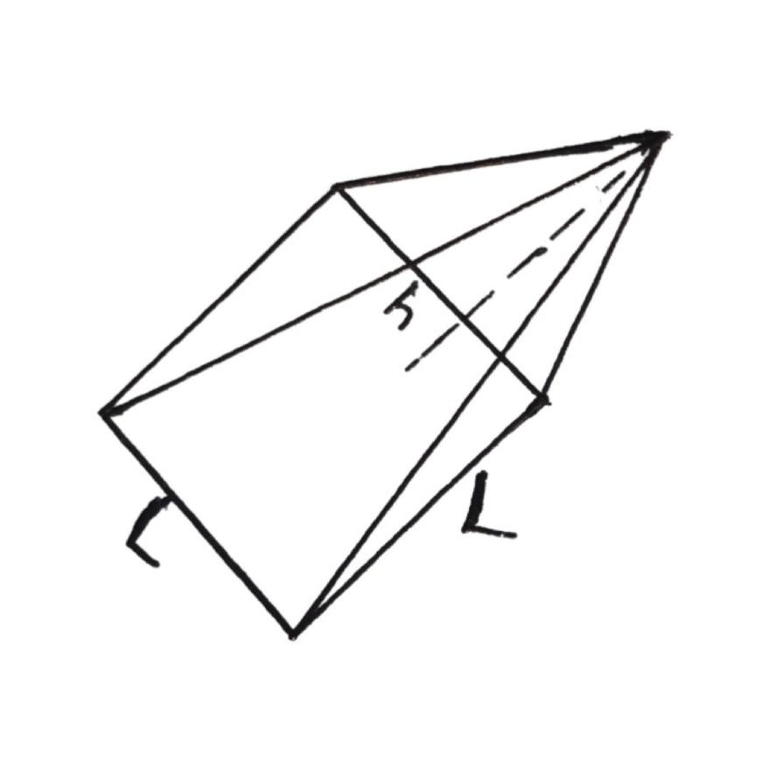

  - RECTANGULAR BASED PYRAMIDS
Volume = $\frac{1}{3}LBH$
The rectangular-based pyramid is simply one-third of the cuboid that forms it.
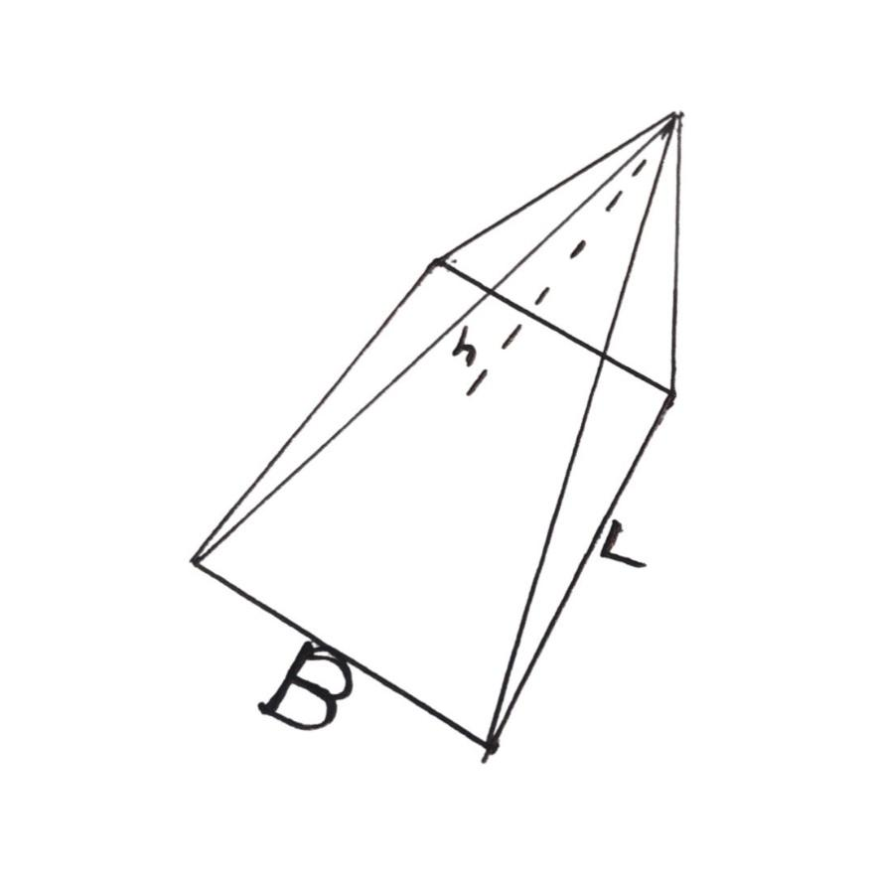

- FRUSTUM
The frustum is the portion of a cone or pyramid remaining after the upper part has been cut off, parallel to the base and maintaining a constant depth. Of course, the upper part that was cut off simply becomes a new, smaller cone with new radius.
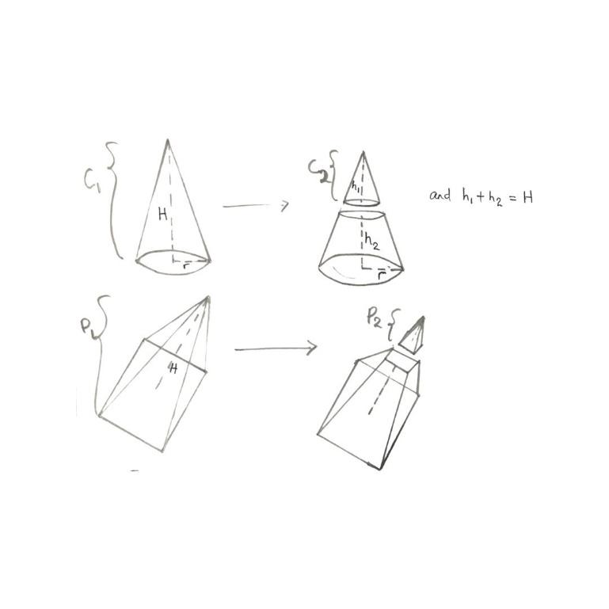

Thus, to find the frustum volume,
Volume of frustum = Volume of original shape – volume of new smaller shape
= volume of $c_{1}$ - volume of $c_{2}$
OR = volume of $p_{1}$ - volume of $p_{2}$

EXAMPLES:
- If the diameter of a cylinder is 4m and its height is 7m, then the C.S.A, T.S.A and the volume of the cylinder.
Diameter(d) = 4m
r = $\frac{d}{2}$= 2m
h = 7m
$$π=\frac{22}{7}$$
- C.S.A = 2$πrh$
= 2$×\frac{22}{7}×2×7$
= 88$m^{2}$
- T.S.A = 2$πr(r+h$)
= 2$×\frac{22}{7}×2(2+7$)
= $\frac{88}{7} \left(9\right)$
= $\frac{792}{7}$
= 113.14$m^{2}$
- Volume = $πr^{2}h$
= $\frac{22}{7}×2^{2}×7$
= 88$m^{3}$
- If a rectangular tank is 18units long, 10 units wide and 15 units high and contains water up to a height of 8 units, then calculate the total surface area, as well as the volume of water contained in the tank.
L= 18units
B= 10 units
H= 15units
Total surface area of a rectangle tank (i.e. T.S.A of cuboid)
= 2(LH +LB+BH)
= 2(18(15) + 18(10) +10(15))
= 2(270 +180+150)
= 2(600)
= 1200 square units.
To find the volume of water contained, the height of water within the tank is 8units; thus
$$H_{w}=8units$$
Volume = LB$H_{w}$
= 18 (10)(8)
= 180(8)
= 1440 cubic units
DRILLS
- A pyramid has a rectangular base with dimensions 6units by 4units, if its height is 7 units, calculate the volume.
- The slant height and radius of base of a cone are 7cm and 5cm respectively. Determine the C.S.A and T.S.A of the cone.
- The volume of a cube is 729$m^{2}$, find the length of its sides.
- The radii of the base of two cylindrical tins, A and B, are r and $\frac{r}{2}$ respectively. If the water level in B is 10 units in height, what would be the height of the same quantity of water in A?
- A cone of radius 15cm and a depth of 14cm is cut cleanly at the top, leaving a frustum and a smaller cone of base radius 7cm. if the frustum has a height of 8 cm, calculate its volume.

SOLUTIONS TO DRILLS
- For a rectangular based pyramid, with dimensions 6 units by 4units and height of 7 units,
Volume =$\frac{1}{3}$LBH
= $\frac{1}{3}\left(6×4×7\right)$
= $2×4×7$
= 56 Cubic units
- Slant height (l) = 7cm
Radius of base(r) = 5cm
$$π=\frac{22}{7}$$
C.S.A= $πrl$
= $\frac{22}{7}×5×7$
= 22$×5$
= 110c$m^{2}$
T.S.A= $πr(r+l)$
= $\frac{22}{7}×5(5+7)$
=$\frac{110}{7}×12$
=$\frac{1320}{7}$
= 188.57c$m^{2}$ (2 d.p)

- Volume of cube= 729$m^{2}=L^{3}$
$L^{3}$ = 729
$L$=$\sqrt[3]{729}$
L = 9m

- $r_{A}=r$
$$r_{B}= \frac{r}{2}$$
$$h_{A}= ?$$
$$h_{B}=10units$$
Volume of water in A = volume of water in B
$$\frac{1}{3}πr_{A}^{2}h_{A} = \frac{1}{3}πr_{B}^{2}h_{B}$$
$$\frac{1}{3}π\left(r^{2}\right)h_{A} = \frac{1}{3}π(\frac{r}{2})^{2} (10)$$
$$\frac{π}{3}\left(r^{2}h_{A}\right) = \frac{π}{3}(\frac{10r^{2}}{4})$$
$r^{2}h_{A} =$ $\frac{10r^{2}}{4}$
$h_{A} = \frac{10}{4}$ = $\frac{5}{2}$
$h_{A}$= 2.5 units
The height level of the same quantity of water in A is 2.5units.

- Radius of cone = 15cm
Height of cone = 14cm
Radius of smaller, cut cone= 7cm
Height of frustum = 8cm
Thus, height of smaller cone = height of cone – height of frustum
= 14cm -8cm
= 6cm
Volume of cone = $\frac{1}{3}πr^{2}h$
= $\frac{1}{3}×\frac{22}{7}×{15}^{2}×14$
= 22$×5×15×2$
= 3300c$m^{3}$

Volume of smaller cone =$\frac{1}{3}πr^{2}h$
= $\frac{1}{3}×\frac{22}{7}×7^{2}×6$
= 22$×7×2$
= 308c$m^{3}$

Volume of frustum= volume of cone – volume of smaller cone
= 3300c$m^{3}$ - 308c$m^{3}$
= 2992c$m^{3}$

